Voltaire Dupo

Vdupo79@gmail.com

Abstract

[Draw your reader in with an engaging abstract. It is typically a short summary of the document.   
When you’re ready to add your content, just click here and start typing.]

Motor control and Drives

By Engr. Voltaire B. Dupo, ECE

Contents

Writers Notes 3

Consideration on Time and Effort 3

Future Work 3

Basic Electrical Structures 5

Relay Sockets and Layout 5

Push Button Switches Type and Connections 6

Lamps / Pilot Lamps 7

DC Motor 7

History 7

Tamiya Motor Datasheet 9

DC Motor Parts 10

DC Motor Typical Failures 10

Activity 1. DC Motor Control 11

Activity 2. DC Motor Control with CW/CCW/Stop 12

Basic NMOS FET Motor Control Circuit 13

Electronic Drivers for DC Motors 15

Datasheet from Texas Instruments Document L293, L293D SLRS008D –SEPTEMBER 1986–REVISED JANUARY 2016 15

Electronic Circuit Application using Arduino UNO Setup as PLC Programmable Device 16

Activity 3. PLC Driven DC Motor Controller 17

Activity 4. PWM Control on DC Motor 17

Controlling DC Motor Speed 17

Activity 5: DC Motor PWM Control 19

Common Gear Mechanisms and their Equations 20

Spur Gears 20

Spur Gear Equations 20

Bevel Gear 21

Worm Drive 22

Types of Worms 22

Advantages of Worm Drives 24

Applications of Worm Gear Drives 24

Knob Wheels 24

Complement of Gears 25

Rotary Encoder 26

Schematic Diagram 26

Wiring Diagram 26

Activity 5. Position Encoder Integration 27

PLC Ladder Diagram 27

AC Motor 28

History 28

AC Motor Design 29

Speed of AC Motors 31

Variable Frequency Drive 31

Digital Panel Control Mode of Fwd/Stop/Rev 31

Testing on Manual Digital Panel Mode 32

Testing using External Control Mode 33

External Frequency Source Mode 33

Common Error Codes 34

Modbus Interface 35

Serial Communication 35

Prog 9-00 Slave ID 35

Prog 9-01 Communications Baud Rate 36

Prog 9-04 Transmission Format 36

Activity 6: AC Motor and VFD Delta S1 36

Stepper Motors 38

History 38

Physical Construction 38

Operation 38

Gear Teeth and Angles Travelled 40

Activity 7: Stepper Motor Operation CW/STOP 41

Controllers 43

Proportional Control 43

Integral Control 43

Derivative Control 44

Activity 8: PID Controller 45

Memory Map 45

Ladder Diagram 45

Schematic Diagram 45

# Writers Notes

This booklet was initially a set of written exercises for the students of DBCS written on the free time of the author not on the time extended and paid for by DBCS. The work presented is from the writer / engineer who had to come up with laboratory materials from a system that was without one for the class.

The original work is covered by an Attribution-NoDerivates 4.0 license which implies that the information here is not freely shared among people and can be used for commercial purposes in this form or in a more refined and edited form. No part of this work can be reproduced and distributed without the prior consent of the Author. That being said this copy is an authorized version that can be shared freely within the Institute of Biomedical Engineering and Health Technology staff, researchers and consultants for their own self education.

## Consideration on Time and Effort

There are of course similar modules online and you probably need around 4 modules or so to complete the same type of course. If each module where priced at around 20 USD per module without taxes. That would set you back around 4000 pesos and spend around 5-8 days figuring out how to connect each module to each other and write the materials.

## Future Work

Future work will be done to document using Controllino to do the some same sort of integration to complete a series that starts and continues on to OMRON Based Automation and Systems Integration. Of course another separate Attribution-NoDerivates 4.0 License will be extended for that work but work will focus more documenting the process of how to use CX-Programmer to do the job.

Preparation for the Course

1. Readers going thru this material for non – audit purposes should at least have taken Basic Electricity, Electrical Wiring, Occupational Health and Safety.
2. Connect the PC/Laptop to the Net
3. They should download Open PLC Editor from <https://openplcproject.com/download/>
4. They should install Open PLC Editor.
5. They should update Open PLC Editor using [Alt] File -> Check for Updates
6. Press the Arduino Icon and Update the compiler dependencies

# Basic Electrical Structures

## Relay Sockets and Layout

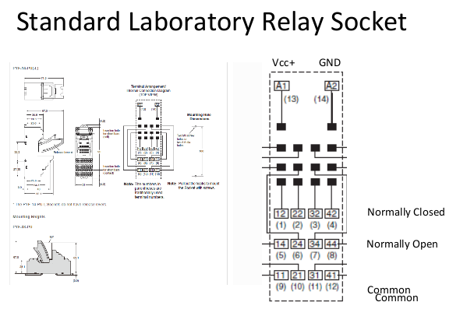

# DC Motor

## History

DC Motors have been around since the inception of the basic motor mechanisms that convert electricity according to the record of known and published history the earliest account of a battery was created by Willian Sturgeon in 1832 (https://www.eti.kit.edu/english/1376.php). This was the first written account of an activity called commutation moving current into a rotating coil. But the invention of the DC motor is largely attributed to Thomas Davenport in 1837 when he created a working model of a geared system to rotate a load. http://edisontechcenter.org/DavenportThomas.html

But going past history how does a motor really operate? To understand this lets go thru the basics and start with the smallest abstraction we have the electron. Electric current is actually just free electrons moving from a source (battery or DC Generator) going to the other terminal to complete the circuit. Electrons emit an electric and magnetic field as they rotate on their axis. The magnetic field established on a coil when current flows thru it was demonstrated in a device created by William Sturgeon in 1825 with his electro magnet. This electromagnet manifests a north and south pole that can interact with a permanent magnet in the response of opposites attracting and like poles repelling each other.

This behaviour led Thomas Davenport to create an appartus with rotating coil assembly that is powered by a set of brush terminals. When the coils are connected to the brush electric current passes thru the coils creating an electromagnet with North and South poles because of the exterior of the apparatus being a permanent magnet this created poles will cause pulling and pushing action to happen as the coil is connected to a rotating center it turns when the pull and push happens causing it to turn and the brush contact to open. As inertia moves the motor in the same direction during the unpowered stage the next coil assembly comes into contact with the windings repeating the cycle again. Brush contacts are subject to arching and carbon buildup while the rotating motion wears out the bearing. In modern DC Motors an inspection and probable replacement happens at around 12000 working hours for a Brushed DC Motor that is built for constant usage it could be lesser for cheaper motors

DC Motors manifest three measurable physical characteristics these are Torque, Speed, Temperature. Among the Three Torque and Speed are mostly associated with its performance while temperature is a consequence of its operation and amount of current passing thru the coil. Electrically speaking a DC motor has a resistance (R) in its winding and an inductance value. (L) As we are using only non-pulsating DC in this normally written off as only concerning the resistance value. In Physics R = pL/A where p is the resistivity of copper coil L is the length of copper wire and A is the diameter of copper wire. Most motors manifest a resistance between 2 - 24 ohms if you measure it. In a non pulsating DC Motor any applied Voltage is changed to current by the formula. I = V / R [Eq 1] since R or Resistance doesn't change then any change in the Voltage V is a change directly proportional to I.

We understand that based on Lorentz Force the amount of physical force that causes the rotation is equal to: F = q(E+[vB]) = qE + qvB [Eq 2] Noting we are only interested in the magnetic circuit we understand that based on the left hand rule current flow (Thumb) creates the BField (Index Finger) and the Force generated (Middle Finger) as such qv can be replaced by I (Electric Current) and L (Lenght of the Inductor) F = qE + ILB [Eq 3] If we consider that I = q/t then F = (I/t)E+ ILB [Eq 4] is our resulting equation set. As such we can see here I determines the amount for force which is directly proportional to the velocity of the rotation (w) If we go back to Eq 1 it shows that for non pulsating DC input to a motor the supplied voltage V now becomes the adjusted value. Torque Torque is defined as the amount of force applied a distance x meters way from a point of rotation in basic mechanics. For a motor Torque is the amount for Force multiplied by a specific distance away from the motor.

Example:

A motor has a torque of 20 kg-cm if a load is placed on a lever 5 cm from the shaft how much is the maximum mass that can be pulled up / down by the motor? Solution: 20kg-cm / 5 cm = 4 kg Torque and Current Relationship in a DC Motor The relationship of Torque and Current input to a motor is a smooth line going up / directly proportional in most cases but at a certain point the torque reaches a maximum value at which no amount of current increase will increase the output torque. Torque and Rotational Speed relationship in DC Motor The relationship of Torque and Speed is inversely proportional. If the speed is at its slowest value the torque is normally higher and the if the speed is at its fastest rotational the torque is at its worst value. For a clearer picture visit this link to see the datasheet of a Tamiya Mabuchi 3v Motor.

## Tamiya Motor Datasheet

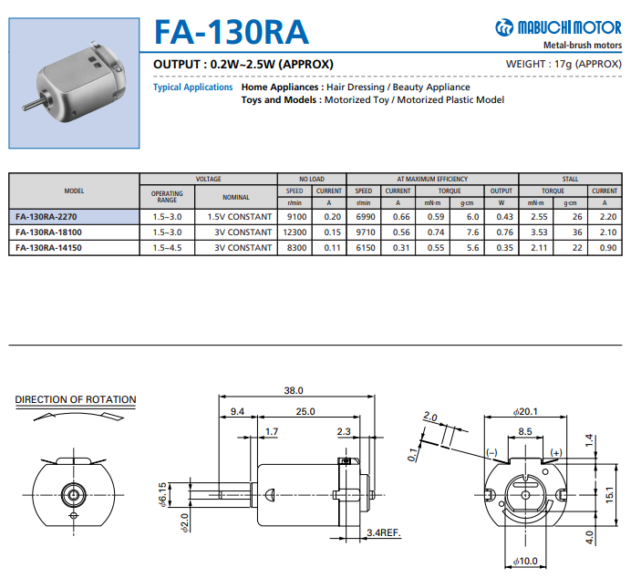

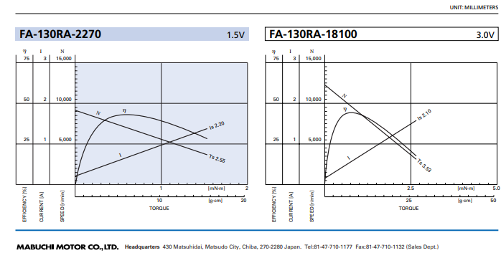

## DC Motor Parts

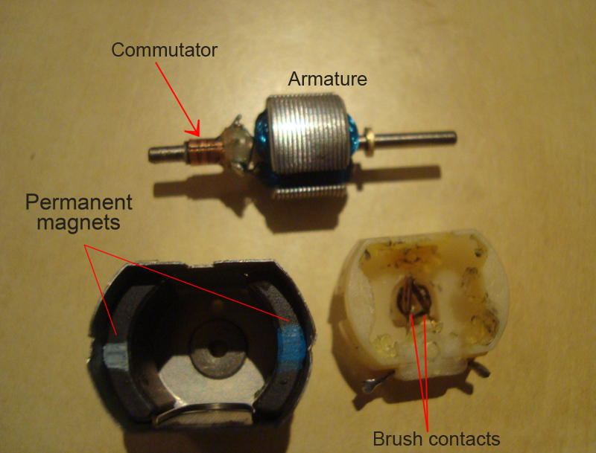

## DC Motor Typical Failures

|  |  |  |
| --- | --- | --- |
| Failure | Reasons | Solution |
| Coil Issue | Burnt Coil – Too much current applied or Voltage Applied beyond operating voltage | Place a fuse between source and the motor. |
| Brush Issue | Worn Out Brushes – Motor has been operating for more than 10,000 hours | Brush Replacement |
| Vibrating Motor | Shaft Issue – Shaft is not straight this is cause for concern and has to be investigated for the reasons behind the issue. | Replace Motor with new one |
|  | Bearing Issue – Bearing is misaligned that leads to shaft wiggling | Bearing Replacement |
| Stuck Motor | Carbon Build up too much inside the motor causes Friction inside the moving parts to increase leading to a stuck motor | Motor Dis-assembly and cleaning. |
|  | Bearing Issue – Bearing is misaligned that leads to shaft wiggling | Bearing Replacement |

## Activity 1. DC Motor Control

## Activity 2. DC Motor Control with CW/CCW/Stop

## Basic NMOS FET Motor Control Circuit

Vs 0---------|<|----------0 + Motor - 0----0 GND

| |

\ /

----------- Q1

--------

^

|

--

| | R

--

Vin0-------|

A DC Motor can be first controlled by the circuit shown in Figure 1. This circuit doesn't allow current from the Vs supply to flow into the NMOS FET Q1 if Vin = 0v. If Vin=5v then current flows from Vs to the NMOS to + Motor Terminal and into the Motor itself coming out of the - Motor Terminal returning to the source - or GND.

In this case the motor only turns on or off it doesnt go Clock Wise or Counter Clockwise. This schematic can be redrawn as Figure 2. Where the Complex Circuitry is replaced by an amplifier.

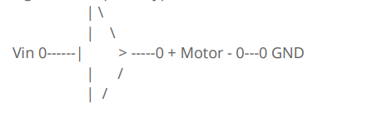

A Schematic Symbol that denotes an Amplifier with a gain of 1. The supply is hidden but there is a Motor Voltage Supply Vs but for the sake of simplifying the illustration its not mentioned. Hence the circuit can be represented as

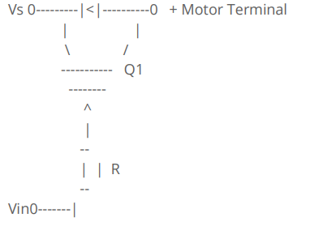

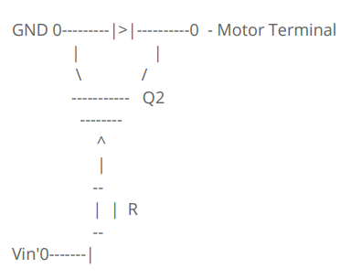

This is preferred since the orientation of the current flow can be clearly controlled in both the Voltage supplied and the motor is se Now to get a motor to function with an option to rotate clockwise or counter Clockwise. Another Schematic that shows this is

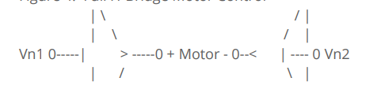

## Electronic Drivers for DC Motors

### Datasheet from Texas Instruments Document L293, L293D SLRS008D –SEPTEMBER 1986–REVISED JANUARY 2016

### Electronic Circuit Application using Arduino UNO Setup as PLC Programmable Device

## Activity 3. PLC Driven DC Motor Controller

## Activity 4. PWM Control on DC Motor

Create a program that can perform DC Pulse Width Modulation (10, 25, 50, 75, 100%)

Check the operation of your Motor for each PWM using a Phone Strobe Tachometer

## Controlling DC Motor Speed

When we look back at the Characteristics of a DC Motor we find out that the current flowing thru the coil which is directly proportional to the applied Voltage to the motor is the main determinant to the speed for the motor.

DC Voltage Applied to the Motor Maximum Speed

5v ----------------------------------------------------------------------------

0v -----------------------------------------------------------------------------

t 0 1 2 3 4 5 6 7 8 9 10 11 12 13 14 15 16 17 18 19 20 21

The signal is 100% on at any given time. For purposes of stating new terms we call this 100% Duty Cycle or the signal is turned on 100% of the time.

DC Voltage Applied to get around 50% - 60% maximum speed

5v

2.5v ----------------------------------------------------------------------------

0v -----------------------------------------------------------------------------

t 0 1 2 3 4 5 6 7 8 9 10 11 12 13 14 15 16 17 18

For the Third signal shown in above it is said to be 50% Duty Cycle since 50% of the time the signal applied is set to high. In motor control this could translate to 50%-60% motor speed control. Computing the Duty Cycle is accomplished by the formula:

Ton

Duty Cycle = ------------- x 100%

Ton + Toff

## Activity 5: DC Motor PWM Control

Create a program using Ladder Diagram (LD) that can toggle between

PWM Modes S1 S2

Off 1 1

25% 0 1

50% 1 0

100% 0 0

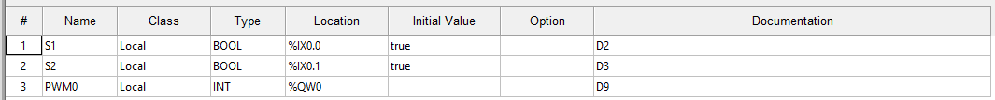

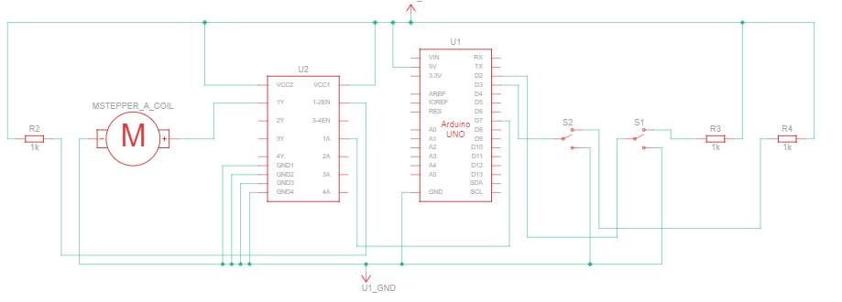

# Common Gear Mechanisms and their Equations

## Spur Gears

## Spur Gear Equations

## Bevel Gear

# Worm Drive

## Types of Worms

## Advantages of Worm Drives

## Knob Wheels

## Complement of Gears

# Rotary Encoder

Rotary Encoders are devices that attach to the motor shaft or moving shaft to determine the present position of the shaft in relation to a specific set starting point.

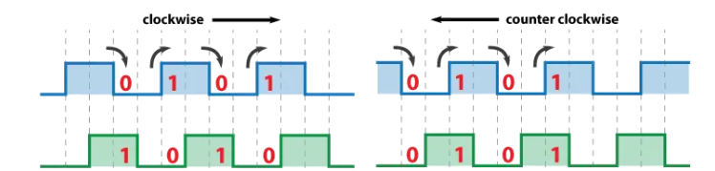

The most basic Rotary Encoder is the one made by Bourns that has 30 switch contacts sending +V to the pins A and then B when any 12 degrees interval is passed thru. The reason for having two outputs is that you can use the non-synchronicity of signals is used to determine direction. If the Blue signal A comes first then the green signal B comes next then it would suggest the motor is rotating clockwise and counter clockwise is signal B comes first then signal A comes next.

## Schematic Diagram

## Wiring Diagram

## Activity 5. Position Encoder Integration

6 – A pin Signal from Encoder

5- Vcc to Encoder

3- Ground to Encoder

## PLC Ladder Diagram

# AC Motor

## History

AC Voltage Generation was pioneered by Nikola Tesla probably genius engineer. AC Voltage never has a set level like DC Voltage. It instead distributes electricity using a continously changing signal going to positive (Vpeak positive) from zero and back to zero then going down to the maximum negative value (Vpeak Negative) and back to zero again this constantly changing voltage level allows it to be distributed without larger sized conductors since the transmission line resistance losses are kept to a minumum. As a distribution system it took over after the technology was deemed easier to put up and maintain.

## AC Motor Design

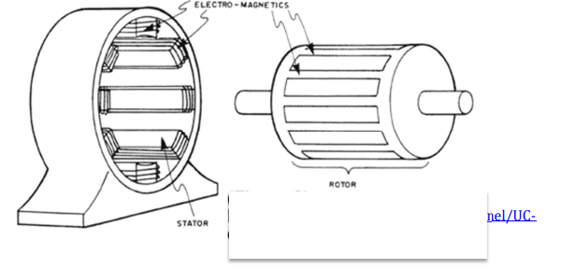

AC Motors have their coils located at the stator not the rotor which makes it easy to differentiate with a standard DC Motor. The AC Motor Coils are basically two coils one primary coil and another auxilliary coils. The Standard AC motor has on its rotor portion what we call rotor bars these if they come in contact with a the coil cores on the stator will induce an electric current. These free electrons will move to thru the rotor end caps that are connected to the end of the rotor rods and the central core shaft. This creates a closed loop and based on lenz law the presence of electric current creates an EMF field.

This emf field interacts with the stator field causing the rotor to move. The problem with AC Motors is that the direction of movement cannot be set by the main coil or primary coil instead this is controlled by the Auxilliary coil.

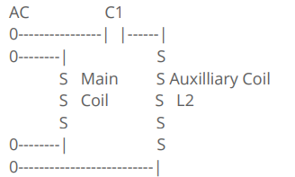

Inductive Coils and AC Voltage

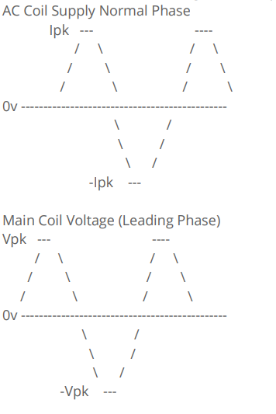

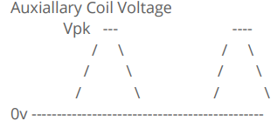

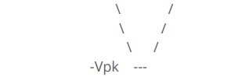

When electric current flows into a coil the resulting Voltage has a leadiing relationship to the current. The presence of C1 in the auxiallary coil causes it to have the same phase as the original source signal or be in the same or near the same phase as the input voltage. This leading main coil and normal auxiallary coil allows the setting of direction of rotation to occur since the main coil will be initially energized to prepare the EMF to move the rotor the auxiallary coils EMF nudges the rotor to start rotating. This is the reason why in home electric fans when the capacitor is faulty and cannot make an out of phase signal at the auxiallary coil you can start the motor spinning my pushing the fan blades by using a pencil that starts the motion to occur.

## Speed of AC Motors

The speed of an AC motor is resolved to be equivalent to the relationship express on the formula below

NS = 120 f p

When NS is the Synchronous Speed of the motor

f is the operating frequency of the unit

p is the number of poles for the motor

# Variable Frequency Drive

A VFD is a variable frequency device which can change the frequency of applied to the power of an AC motors this in turn changes the speed of the AC Motor.

### Digital Panel Control Mode of Fwd/Stop/Rev

a. Connect the L1 - L2 to R and S Terminals

b. Connect the Single Phase Motor to U and V Terminals.

c. Turn Motor On by Pressing Run

#### Troubleshooting if the Panel Control Doesn’t Work but the display

#### shows Fxx.x

If Motor Doesn't Run Turn on the Digital Panel Control by

1. Frequency Output or Fxx.x Output of the display

2. Pressing Prog Button Once

3. Pressing Up Button Twice to reach 2

4. Pressing Prog Button Upon reaching 2

5. Pressing Up Once to reach 2-01 on the screen

6. Press Data Button Once to load the data

7. Press Arrow Up / Down Buttons to make the value on the display be |d 0|

8. Press Prog Button to load changes

9. Wait for the End Message to confirm changes to control source.

## Testing on Manual Digital Panel Mode

Turn Motor Off by Pressing Stop

Adjust Speed using the Potentiometer on the Digital Panel.

After Tests go well. Power Down the Unit

Processing External Control Mode for CW/CCW

Wire two push button switches to the M0 and M1 respectively while the other side of the

switch is connected to GND connector from the VFD-S1 External Wiring Box.

Power Up the Unit upon completing the Activity

Once the unit display Frequency or |F60.0 | then you may setup the unit to work from the

remotely wired switches by:

1. Frequency Output or Fxx.x Output of the display

2. Pressing Prog Button Once

3. Pressing Up Button Twice to reach 2

4. Pressing Prog Button Upon reaching 2

5. Pressing Up Once to reach 2-01 on the screen

6. Press Data Button Once to load the data

7. Press Arrow Up / Down Buttons to make the value on the display be |d 1|

d0: Digital Keypad

d1: External terminals. Keypad STOP/RESET enabled.

d2: External terminals. Keypad STOP/RESET disabled.

d3: RS-485 serial communication (RJ-11) .Keypad STOP/RESET enabled.

d4: RS-485 serial communication (RJ-11). Keypad STOP/RESET disabled.

8. Press Prog Button to load changes

9. Wait for the End Message to confirm changes to control source.

### Testing using External Control Mode

Test that by pressing S1 (M0) your motor moves CW.

By Pressing S2(M1) and S1(M0) your motor moves CCW.

### External Frequency Source Mode

1. Make sure the device is at stopped.

2. Press the Prog Button

3. Use the Up / down keys to get to option 2 or option 2-xx

4. Press the Prog Button

5. Use the up / down key until it reaches 2-00

6. Press the Prog Button

7. Choose the Option d 1 by using the up down button

8. Press the Prog Button once you are on the d 1.

• d0: Master Frequency input determined by digital keypad. (record the

frequency of power loss and it can do analog overlap plus)

• d1: Master Frequency determined by analog signal DC 0V-10V (external

terminal AVI). (won't record the frequency of power loss and it can't do analog

overlap plus)

• d4: Master Frequency operated by RS-485 serial communication interface and

record frequency of power loss. (record the frequency of power loss and it can

do analog overlap plus)

9. Wait for the End Message to confirm changes to control source.

10. Choose the Option 2-06 by using the up down button

11. Choose the Option d 1 by using the up down button

• d0: Disabled

• d1: Enable + AVI

• d2: Enable + ACI

12. Press the Prog Button once you are at 2-06 d 1

13. Wait for the End Message to confirm changes to control source.

14. You may now start to use the External Potentionmeter

### Common Error Codes

• 0: No fault

• d1: Over current (oc)

• d2: Over voltage (ov)

• d3: Over heat (oH)

• d4: Over load (oL)

• d5: Over load (oL1)

• d6: External fault (EF)

• d7: Reserved

• d8: Reserved

• d9: Excess current during

• acceleration (ocA)

• d10: Excess current during

• deceleration (ocd)

• d11: Excess current during steady

• state (ocn)

• d12: Ground fault (GF)

• d13: Reserved

• d14: Low voltage (Lv)

• d15: CPU failure 1 (cF1)

• d16: CPU failure 2 (cF2)

• d17: Base block (b.b.)

• d18: Overload (oL2)

• d19: Auto acceleration/deceleration

• failure (cFA)

• d20: Software protection enable (codE)

• d21: Reserved

• d22: CPU failure (cF3.1)

• d23: CPU failure (cF3.2)

• d24: CPU failure (cF3.3)

• d25: CPU failure (cF3.4)

• d26: CPU failure (cF3.5)

• d27: CPU failure (cF3.6)

• d28: CPU failure (cF3.7)

• d29: Hardware protection failure

• (HPF.1)

• d30: Hardware protection failure

• (HPF.2)

• d31: Hardware protection failure

• (HPF.3)

• d32: Communication time-out

• (CE10)

• d33: Reserved

• d34: Software error (SErr)

• d35: Reserved

• d36: PID error (Pld)

• d37: Reserved

• d38: Phase loss (PHL)

# Modbus Interface

## Serial Communication

### Prog 9-00 Slave ID

D 1-254

### Prog 9-01 Communications Baud Rate

d0: Baud Rate 4800 bps

d1: Baud Rate 9600 bps

d2: Baud Rate 19200 bps

d3: Baud Rate 38400 bps

### Prog 9-04 Transmission Format

d0: 7,N,2 (Modbus, ASCII)

d1: 7,E,1 (Modbus, ASCII)

d2: 7,O,1 (Modbus, ASCII)

d3: 8,N,2 (Modbus, ASCII)

d4: 8,E,1 (Modbus, ASCII)

d5: 8,O,1 (Modbus, ASCII)

d6: 8,N,2 (Modbus, RTU)

d7: 8,E,1 (Modbus, RTU)

d8: 8,O,1 (Modbus, RTU)

## Activity 6: AC Motor and VFD Delta S1

Preparation  
Connect the L1 - L2 to R and S Terminals  
Connect the Single Phase Motor to U and V Terminals.  
Turn Motor On by Pressing Run  
If Motor Doesn't Run Turn on the Digital Panel Control by  
1.  Frequency Output or Fxx.x Output of the display   
2. Pressing Prog Button Once  
3. Pressing Up Button Twice to reach 2  
4. Pressing Prog Button Upon reaching 2  
5. Pressing Up Once to reach 2-01 on the screen  
6. Press Data Button Once to load the data  
7. Press Arrow Up / Down Buttons to make the value on the display be |d   0|  
8. Press Prog Button to load changes  
9. Wait for the End Message to confirm changes to control source.  
  
Turn Motor Off by Pressing Stop  
Adjust Speed using the Potentiometer on the Digital Panel.  
After Tests go well. Power Down the Unit  
  
Process  
  
Wire two push button switches to the M0 and M1 respectively while the other side of the switch is connected to GND connector from the VFD-S1 External Wiring Box.  
Power Up the Unit upon completing the Activity  
Once the unit display Frequency or |F60.0 | then you may setup the unit to work from the remotely wired switches by:  
1.  Frequency Output or Fxx.x Output of the display   
2. Pressing Prog Button Once  
3. Pressing Up Button Twice to reach 2  
4. Pressing Prog Button Upon reaching 2  
5. Pressing Up Once to reach 2-01 on the screen  
6. Press Data Button Once to load the data  
7. Press Arrow Up / Down Buttons to make the value on the display be |d   1|  
8. Press Prog Button to load changes  
9. Wait for the End Message to confirm changes to control source.  
  
Testing  
  
Test that by pressing S1 (M0) your motor moves CW.   
By Pressing S2(M1) and S1(M0) your motor moves CCW.

# Stepper Motors

## History

Stepper Motors are one of the most useful motors in the current state of the technology in 2021. They are cheap to make but provide accuracy to a certain degree. History of Stepper Motors The attribution to the creation of the Stepper motor is mostly held by Frank Woods who holds the patent ( https://patents.google.com/patent/US1408555 ) for a 5 coil motor that uses pulses to control its movement. The patent was filed in 1918. The British Empires Military Engineers where to fit a working model of the Stepper Motor and fitted it in the gun control positioning systems in their warships this was in 1930. What is amazing about this motor is that in an age of analog computers (1800s - 1930s) the ability to accurately control motors was most probably just a dream that engineers and technicians would have in the early 1900s to 1940. But the simplicity of the design and usage of this motor allows it to be used easily with current state of the technology in the 1930s.

## Physical Construction

Stepper Motors are fitted with three coil groups with Two pairs of physical coils for each group. These are found on the stator of the stepper motor not the rotor like in DC Motors. Each coil pair are wound on a iron core with gear teeth on the South and North poles of the two coils respectively. These gear teeth are the ways the stator coils interact with the Rotor. The Rotor of a Stepper Motor is made out of Magnetised Iron Core with two end caps with gear teeth. If we classify the gear teeth grouping for a three coil setup (Red, Green Yellow) we can say that: The Red Gear Teeth align perfectly with the Rotor gear teeth. The Green Gear Teeth align 50% with the Rotor gear Teeth they come in close proximity with. The Yellow Gear Teeth are fully misaligned with the gear teeth they are in close proximity with.

## Operation

Lets divide the operation into two areas the electric side and the magnetic side.

Electric Side

1. The coil 1 Yellow is energized or current passed thru it.
2. Current passing thru the coil causes the creation of a magnetic field. the runs along the length of the iron core. Magnetic Side
3. The magnetic field leaves the Iron Core via the gear teeth and comes in contact with the ferrite core of the rotor.

Physical Side

1. The ferrite cores misaligned teeth are attracted to the polarity of the of the stator coil yellow that is energized causing the rotor to shift to turn to be aligned with the stator teeth.

Electrical Side

1. The Yellow Coil is powered down current slowly goes down.

Magnetic Side

1. Due to the decreasing electric current the magnetic field collapses but no motion is recorded on the rotor.
2. Electric Side:
3. The coil 2 Red is energized or current passed thru it.
4. Current passing thru the coil causes the creation of a magnetic field. the runs along the length of the iron core.

Magnetic Side

1. The magnetic field leaves the Iron Core via the gear teeth and comes in contact with the ferrite core of the rotor.

Physical Side

1. The ferrite cores misaligned teeth in reference to the red gear teeth are attracted to the polarity of the of the stator coil red that is energized causing the rotor to shift or turn to be aligned with the stator teeth.

Electrical Side

1. The Coil 2 (Red) is powered down current slowly goes down.

Magnetic Side

1. Due to the decreasing electric current the magnetic field collapses but no motion is recorded on the rotor.

Electric Side:

1. 13. The coil 3 (green) is energized or current passed thru it.
2. Current passing thru the coil causes the creation of a magnetic field. the runs along the length of the iron core.

Magnetic Side

1. The magnetic field leaves the Iron Core via the gear teeth and comes in contact with the ferrite core of the rotor.

Physical Side

1. The ferrite cores teeth are aligned teeth 50% reference to the green gear teeth are attracted to the polarity of the of the stator coil red that is energized causing the rotor to shift or turn to be aligned with the stator teeth.

Electrical Side

1. The Coil 3 (Green) is powered down current slowly goes down.

Magnetic Side

1. Due to the decreasing electric current the magnetic field collapses but no motion is recorded on the rotor.

Physical Side

1. This completes one full step of the stepper motor.

## Gear Teeth and Angles Travelled

The number of gear teeth determines the angular position that the motor travels.

For example you have a 48 gear teeth for it to comple 1 Revolution which is 360 degrees you need 7.5 steps or simply put it 8 steps.

## Activity 7: Stepper Motor Operation CW/STOP

Create a program what Uses ULN2003 or L293D Driver to operate a stepper motor

## Controllers

A controller is an active device that changes an applied signal to cause a load (motor, lamp, heater or pressure transducer). Controllers take its input from the difference between a set point and the actual condition of the load (temperature/position/pressure) applied to the system.

### Proportional Control

The basic continuous control mode is “proportional control”.  With proportional control the controller output is algebraically proportional to the error input signal to the controller.

### Integral Control

Also known as Reset (integral) action. This type of controller provides a signal which depends on the size of the error signal.  It is different from proportional control because it will continue to cancel any error until the offset is zero.

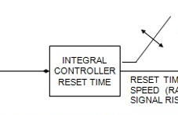

For this type of control action is combined with proportional control action.  This combination is called proportional-reset or proportional-integral action (PI control).  This combination provides a control action which is stable and responds quickly with no offset.

### Derivative Control

Derivative (rate) control action produces an output signal which is proportional to how fast the error signal changes (its rate).

This type of control is only used when the loop response is very slow.  Using derivative control on a loop which responds to changes quickly is dangerous.  The output moves too quickly to a maximum or a minimum and can produce shock waves in the process being controlled.

In OpenPLC PID controller is set on one functional block

|  |  |
| --- | --- |
|  | Auto is the Boolean input if set high allows the block to function.  PV is the Preset Value or final end number for the ramp signal  SP is the set point of deviation for the ramp signal.  X0 is the starting value of the analog input  KP is the proportional controller multiplier  TR is the Integral controller multiplier  TD is the Derivative controller multiplier  Cycle is the number of seconds required to move the value from X0 value to PV value. |

## Activity 8: PID Controller

### Memory Map

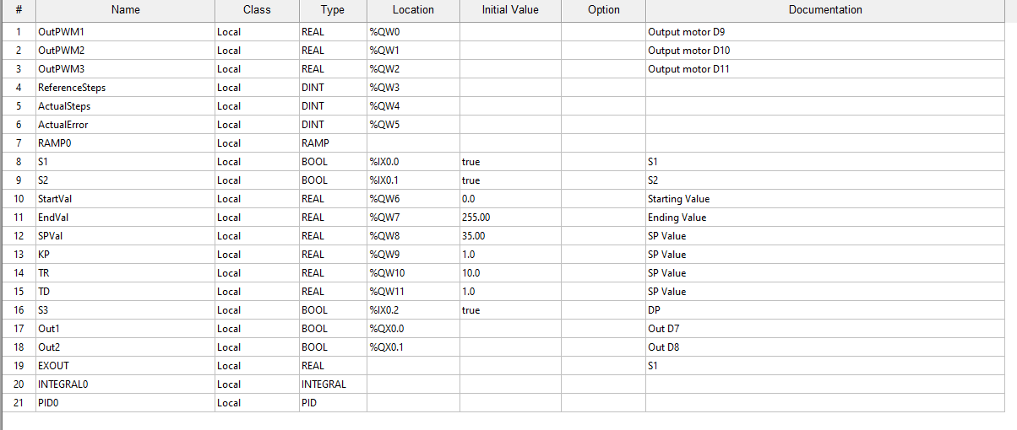

### Ladder Diagram

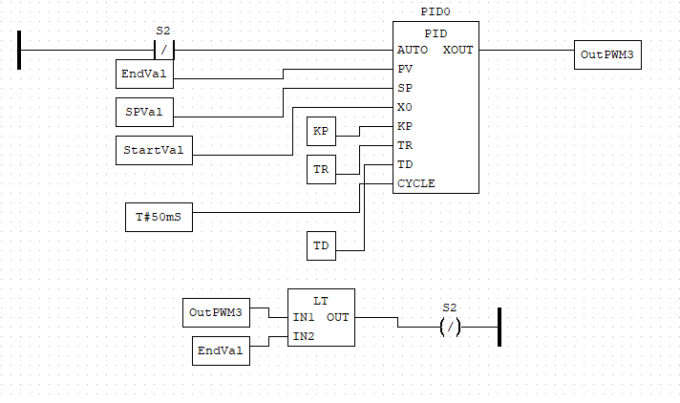

### Schematic Diagram

